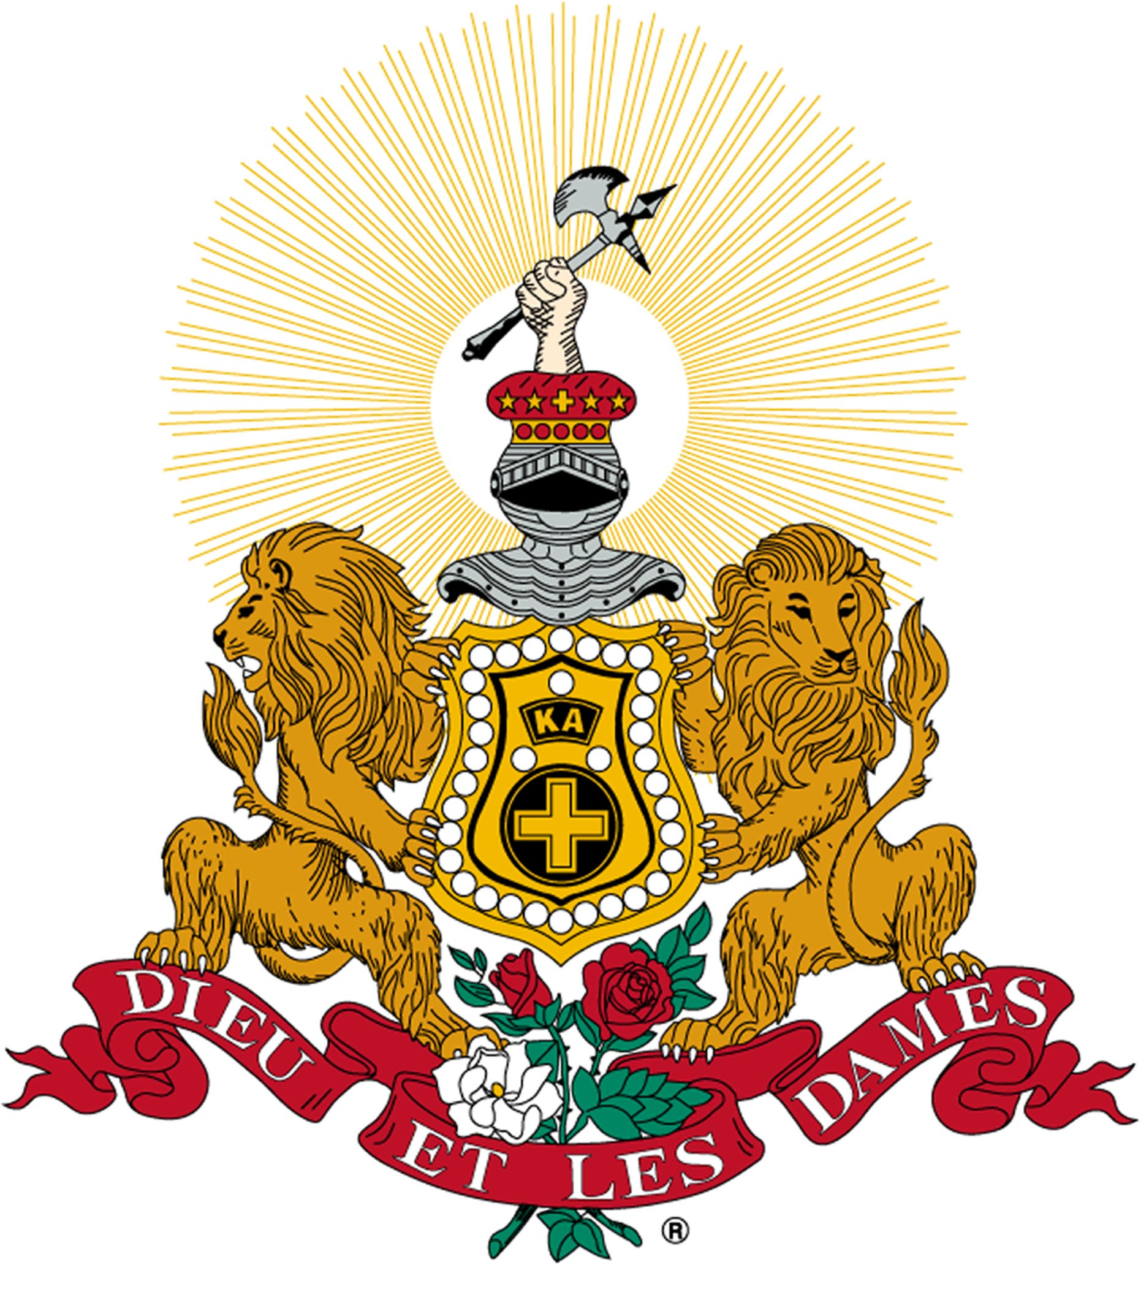
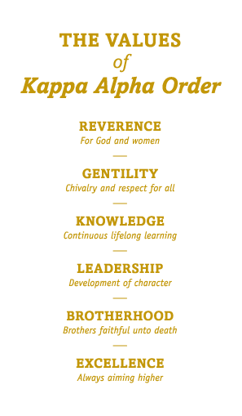
KAPPA ALPHA ORDER

Rose Ball Formal
& Awards Banquet

Omega Omega Chapter at State University

March 1, 2019

Venue Name
City, State

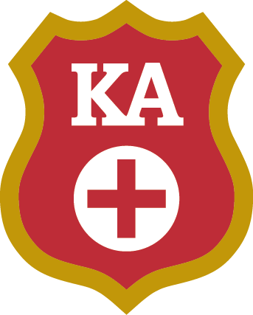
Kappa Alpha Order’s shared values of reverence, gentility, knowledge, leadership, brotherhood, and excellence are what defines KA as a moral compass for the modern gentleman. In 1865 our founders, James Ward Wood, William Nelson Scott, Stanhope McClelland Scott, and William Archibald Walsh, were four of forty students at Washington College, now Washington & Lee University. They originated and began our Order. Samuel Zenas Ammen, who is noted as our practical founder, expanded the Order across the country, modernized many aspects, and served as Knight Commander twice in his lifetime.

In our 153 year history, there have been many successful members and alumni such as GEN George C. Marshall, GEN George S. Patton, Former Secretary of State Dean Rusk, Former Secretary of Defense Caleb Boggs, and Former Speaker of the U.S. House of Representatives Carl Albert, along with more than 165,000 individuals who compose the true fabric of our fraternity. Their daily application of our values are what defines KA.

The Omega Omega Chapter was founded in 1905 at State University in City/Town, State.
Program

Welcome
Joe Smith, Number I

Invocation
Bob Jones, Number IX

- Dinner -
Baby Greens Salad
Tenderloin Medallion & Asiago Chicken
with Sautéed Green Beans & Potato Souffle
Turtle Cheesecake

Presentation of Academic Awards
Don Davis, Number III

Presentation of Brother of the Year
Jacob Brown, Number II

KA Rose
Recognition Ceremony
Joe Smith, Number I

Benediction
Bob Jones, Number IX

